**VISVESVARAYA TECHNOLOGICAL UNIVERSITY**

**JNANASANGAMA, BELGAVI-590018**

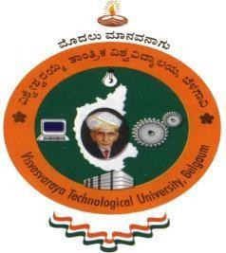

**AICTE ACTIVITY POINTS REPORT**

Submitted in partial fulfilment of the requirements for the award of degree

**Submitted by**

|  |
| --- |
| **YUVANYASH MOORTHY RAMESHBABU** |

**1BI19IS063**

Under the Guidance of Dr. C S Jayasheela

Assistant Professor

Dept of ISE, BIT

Organized by

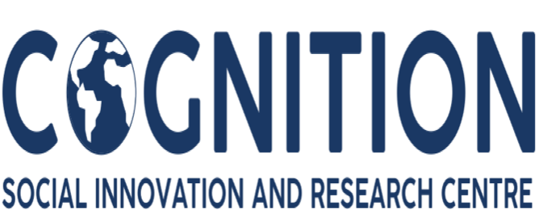

&

SKILL DEVELOPMENT CENTRE & CICC, BIT IN

COLLABORATION WITH

KARNATAKA SCIENCE AND TECHNOLOGY ACADEMY(KSTA)

Bangalore, India



**2022-2023**

**DEPARTMENT OF INFORMATION SCIENCE AND ENGINEERING BANGALORE INSTITUTE OF TECHNOLOGY**

**K. R. Road, V. V. Pura, Bengaluru-560004**

 **VISVESVARAYA TECHNOLOGICAL UNIVERSITY**

### “Jnana Sangama”, Belagaum-590018, Karnataka

**BANGALORE INSTITUTE OF TECHNOLOGY**

### K.R. Road, V.V. Puram, Bengaluru-560004

**DEPARTMENT OF INFORMATION SCIENCE & ENGINEERING**

# CERTIFICATE

This is to certify that **Mr. YUVANYASH MOORTHY RAMESH BABU** bearing USN **1BI19IS063** is a bonafide student and has actively involved in AICTE Activities organized by Cognition and successfully completed the all the activities for the partial fulfilment for the award of degree of Bachelor of Engineering in Information Science and Engineering under Visvesvaraya Technological University, Belagavi during the year 2022-2023. The report has been approved as it satisfies the requirements in respect of AICTE Activity.

## Activity Points Earned: 50 points

**______________________________________**

**Dr. C S Jayasheela**

Assistant Professor

Dept of ISE, BIT

# ABSTRACT

The objectives of AICTE student activity is to expose students to real-time life challenges, to provide the opportunity to gather data, analyze data, propose solutions and implement solutions. Also, it paves the way for personal development and creative engineers who are proud volunteers with a sense of achievement and ready to take up projects having a social impact and creating digital awareness. Besides, it helps the students to strengthen their soft skills, leadership qualities and team spirit. Moreover, these activities inculcate entrepreneurial mindset and societal commitment. Apart from technical knowledge and skills, to be successful as professionals, students should have excellent soft skills, leadership qualities and team spirit. They should have entrepreneurial capabilities and societal commitment.

**ACKNOWLEDGEMENT**

The satisfaction and euphoria that accompanies the successful completion of any task would be incomplete without complementing those who made it possible and whose guidance and encouragement made my efforts successful. So, my sincere thanks to all those who have supported me in completing this Activity successfully.

My sincere thanks to **Dr. M. U. Aswath**, Principal, BIT and **Asha T**, Associate professor, Department of ISE, BIT and **Dr. Vasanth Kumar**, Assistant professor, Department of Mech Engineering and **Mrs. C S Jayasheela**, Assistant Professor, Department of ISE, BIT for their encouragement, support and guidance to the student community in all fields of education. I am grateful to our institution for providing us a congenial atmosphere to carry out the Activity successfully.

I extend my sincere thanks to all the department faculty members and non-teaching staff for supporting me directly or indirectly in the completion of this Activity.

### YUVANYASH MOORTHY RAMESHBABU

### 1BI19IS063

**TABLE OF CONTENTS**

|  |  |  |
| --- | --- | --- |
| **Chapter** | **Title** | **Page No** |
| 1 | INTRODUCTION | 01 |
| 2 | ABOUT THE ORGANIZING DEPARTMENT | 03 |
|  | 2.1 Projects | 03 |
| 3 | DESCRIPTION OF AICTE ACTIVITES CONDUCTED | 04 |
|  | Activity 1: Developing an Efficient Garbage Disposal System | 04 |
|  | 3.1.1 Introduction | 04 |
|  | 3.1.2 Importance of Segregation of Wet and Dry Waste | 05 |
|  | 3.1.3 Activities Conducted | 07 |
|  | 3.1.4 Observations and Learnings | 08 |
|  | 3.1.5 Attachments | 09 |
|  | 3.1.6 Certificate | 14 |
|  | Activity 2: 100% Digitized Transaction | 15 |
|  | 3.2.1 Introduction | 15 |
|  | 3.2.2 Meaning of 100% Digitized Transaction | 17 |
|  | 3.2.3 Activities Conducted | 19 |
|  | 3.2.4 Results and Findings | 19 |
|  | 3.2.5 Observations and Learnings | 20 |
|  | 3.2.6 Attachments | 21 |
|  | 3.2.7 Certificate | 30 |
|  | Activity 3: Swachh Bharat | 84 |
|  | 3.5.1 Introduction | 84 |
|  | 3.5.2 Impact of Swachh Bharat Mission on Environment | 86 |
|  | 3.5.3 Activities Conducted | 88 |
|  | 3.5.4 Outcome of the Activity | 88 |
|  | 3.5.5 Observations and Learnings | 89 |
|  | 3.5.6 Attachments | 90 |
|  | 3.5.7 Certificate | 93 |
|  | Activity 6: Spreading Public Awareness Under Rural Outreach Programmes | 94 |
|  | 3.4.1 Introduction | 94 |
|  | 3.4.2 Activities Conducted | 95 |
|  | 3.4.3 Results and Findings | 99 |
|  | 3.4.5 Attachments | 101 |
|  | 3.4.6 Certificate | 104 |
| 4 | REFERENCES | 105 |
|  |  |  |
|  |  |  |
|  |  |  |
|  |  |  |
|  |  |  |
|  |  |  |
|  |  |  |
|  |  |  |
|  |  |  |
|  |  |  |
|  |  |  |
|  |  |  |
|  |  |  |
|  |  |  |

**LIST OF FIGURES**

|  |  |  |
| --- | --- | --- |
| **Figure No.** | **Figure Title** | **Page No.** |
| 1 | Dry and Wet waste Segregation I | 48 |
| 2 | Dry and Wet waste Segregation II | 48 |
| 3 | Dry and Wet waste Segregation III | 49 |
| 4 | Dry and Wet waste Segregation IV | 49 |
| 5 | Before and After Segregating Waste | 50 |
| 6 | Waste segregation post to motivate others also to follow | 51 |
| 7 | Paper bag making I | 52 |
| 8 | Distribution of Paper bag | 52 |
| 9 | Plant Activity Step I | 53 |
| 10 | Plant growth after some days-I | 53 |
| 11 | Plant growth after some days-II | 54 |
| 12 | Plant growth after some days-III | 54 |
| 13 | Fairy Light Activity | 61 |
| 14 | Spreading awareness through social media post | 62 |
| 15 | Game Night | 62 |
| 16 | Social Media Awareness for reducing gadget usage | 63 |
| 17 | Checklist | 63 |
| 18 | Digital Poster for Conservation of Energy | 64 |
| 19 | Social Media Post about energy | 64 |
| 20 | Vision Board | 65 |
| 21 | Survey Pictures I | 73 |
| 22 | Survey Pictures II | 73 |
| 23 | Survey Pictures III | 74 |
| 24 | Survey Pictures IV | 74 |
| 25 | Lake Cleaning Activity I | 90 |
| 26 | Lake Cleaning Activity II | 90 |

|  |  |  |
| --- | --- | --- |
| 27 | Lake Cleaning Activity III | 91 |
| 28 | Lake Cleaning Activity IV | 91 |
| 29 | Lake Cleaning Activity V | 92 |
| 30 | Lake Cleaning Activity VI | 92 |
| 31 | Medical Awareness I | 101 |
| 32 | Medical Awareness II | 101 |
| 33 | Medical Awareness III | 102 |
| 34 | Medical Awareness IV | 102 |
| 35 | Medical Awareness V | 103 |

**1.INTRODUCTION**

The objectives of AICTE student activity is to expose students to real-time life challenges, to provide the opportunity to gather data, analyse data, propose solutions and implement solutions. Also, it paves the way for personal development and creative engineers who are proud volunteers with a sense of achievement and ready to take up projects having a social impact and creating digital awareness. Besides, it helps the students to strengthen their soft skills, leadership qualities and team spirit. Moreover, these activities inculcate entrepreneurial mindset and societal commitment.

Apart from technical knowledge and skills, to be successful as professionals, students should have excellent soft skills, leadership qualities and team spirit. They should have entrepreneurial capabilities and societal commitment. In order to match these multifarious requirements, AICTE has created a unique mechanism of awarding minimum100 Activity Points over and above the academic grades. Every regular student, who is admitted to the 4 years Degree programme, is required to earn 100 Activity Points in addition to the required academic grades, for getting 4 Years degree programme. Students entering 4 years Degree programme through lateral entry are required to earn 75 Activity Points, in addition to the academic grades, for getting 4 years’ degree program. Similarly, Diploma students are required to earn 75 Activity Points during 3 years of their diploma programme. AICTE recommends 300-400 hours Activity Programme for each degree student for Community service and allied activities. Similarly, 200-250 hours should be devoted by Diploma student for Community service and allied activities as an additional requirement or non-credit programme. Here, 40-45 hours are equivalent to 1 week. These activities will be coordinated by NSS/NCC/CICC/Sports/SAGY Coordinator or TPO of the Institute. The student will be provided a certificate from the concerned coordinator and Institutional Head. Every student is required to prepare a file containing documentary proofs of activities, done by him/ her. The student should earn at least 100 activity points before he/ she appears for his/ her Final Examinations. The points students have earned will be reflected on the student’s transcript. However, there will be neither grades/ marks for these points nor will there be any effect on SPI/CPI/CGPA etc. As proposed under the AICTE Rural Internship Programme, if a student completes any long-term goal during his degree programme, it will be counted as Internship Activity and credit requirement for the internship is fulfilled. However, if only short-term interventions under the programme are attempted it will be counted towards AICTE Activity Point Programme requisite.

Following suggestive activities as long term Goals may be carried out by students in teams:

1. Prepare and implement plan to create local job opportunities.
2. Prepare and implement plan to improve education quality in village.
3. Prepare an actionable DPR for Doubling the village Income.
4. Developing Sustainable Water Management system.
5. Prepare and improve a plan to improve health parameters of villagers.
6. Developing and implementing of low-cost Sanitation facilities.
7. Prepare and implement plan to promote Local Tourism through Innovative Approaches.
8. Implement/Develop Technology solutions which will improve quality of life.
9. Prepare and implement solution for energy conservation.
10. Prepare and implement plan to Skill village youth and provide employment.
11. Develop localized techniques for Reduction in construction Cost.
12. Prepare and implement plan of sustainable growth of village.
13. Setting of Information imparting club for women leading to contribution in social and economic issues.
14. Developing and managing Efficient garbage disposable system.
15. Contribution to any national level initiative of Government of India. For eg. Digital India/ Skill India/ Swachh Bharat Internship etc

The student may choose any activities as per their liking in order to earn the AICTE Activity points. These activities can be spread over the years, as per convenience of the student.

But due to the covid-19 pandemic the points to be earned by every regular student is reduced to 50 points and for lateral entry student it is reduced to 25 points.

Following are the various activities conducted by the institution to enable AICTE activity points.

1. Creating public awareness to upskill rural people under rural outreach programme (Rural India).
2. Helping local schools to achieve good result and enhance their enrolment in Higher/ technical/ Vocational Education.

3.Contribution to National level Initiative of Government of India (Digital India/Skill India).

**2.****ABOUT THE ORGANIZING DEPARTMENT**

The AICTE activities were organized by Cognition.

Cognition had formed a volunteer group, where they started working towards Global Sustainable Development Goals like Zero Hunger and Quality Education. They collect good and hygiene excess food from the functions and gatherings, and distribute it to the community where people are short of quality meals on daily basis and also create awareness in schools, offices, public spaces and in community about food wastage and food management.

This work is being carried out since two years and they have by now served around 250000 people with quality meals through their initiative. Food which was supposed to be wasted or thrown on streets and drainage even before getting spoiled was being given to the needy people. All this work is to fight zero hunger while they have also done some work to fight quality education. They have set up 27 libraries in govt schools across Ballari district to promote quality education and to make children interested in reading. They also conduct awareness program for women safety and hygiene, Menstrual Hygiene, Food wastage and efficient management, education and career goals. As a part of weekly activity and to provide quality education, they also engage in teaching students of an Orphanage with our fellow volunteers. This social service has made our friends and relatives to also get involved in serving the society and down trodden.

**2.1 Projects**

**1.Good Health and Well Being**

Health is a state of complete harmony of the body, mind and spirit.  
A healthy body nourishes a healthy mind. Working for quality education directly stimulates us to work for health and well being. In order to promote good mental and physical health, they conduct awareness programme related to personal health, menstrual hygiene, mental health etc.

**2.Awareness Programs**

Any big change we expect to see in the society begins with a small step. Awareness programme are very effective in that move towards sustainability. The most important group of people who needs awareness are the youth who will be ruling the future.

## Skill Development Centre:

The higher education of the 21st century faces several challenges in providing skill-centric learning, meeting the needs of the industry and society in the global arena. In order to overcome such challenges, Bangalore Institute of Technology (BIT) aims to upgrade skills to universal standards through significant industry participation and develop necessary frameworks of standards for quality assurance. The institute believes that skills are as essential as one's academic status. Thus, education and skills should go hand in hand to empower students, safeguard their future, and the overall development of an individual.

Objectives of Skill Development Centre:

* To conduct various skill development programs to students and improve their employability.
* To promote entrepreneurship to address societal issues.
* To endorse the knowledge exchange programs.
* To increase employability, leadership qualities of faculty and students.
* To improve the technical and writing skills and researchable activities of faculty and students.
* To facilitate the industrial institutional interactions.
* Improvement in the learning potentialities and enhancing self-confidence of faculty and students.
* Preparing women for economic independence.

Members of the Committee:

|  |  |  |
| --- | --- | --- |
| SL No | Members | Designation |
| 1. | Dr Roopa K M | Dean |
| 2. | Dr Gunavathi | Associate Dean |

## 2.3 College Internal Complaint Cell (CICC):

The vision of the Cell is to provide a healthy and safety environment to uphold the dignity othe Students and Employees.

Objectives of CICC:

* To build self-confidence and nobility among employees of the institution.
* To create awareness regarding women rights.
* To avoid and forbid sexual harassment at workplace.
* To promote counselling, legal aid in case of harassment against employees.

Members of the Committee:

|  |  |  |
| --- | --- | --- |
| SL No | Members | Designation |
| 1. | Dr Roopa K M | Coordinator |

## 2.4 Karnataka Science and Technology Academy:

The Karnataka Science and Technology Academy (KSTA) is an organization established in 2005 to promote [science](https://en.wikipedia.org/wiki/Science) and [technology](https://en.wikipedia.org/wiki/Technology)-related activities in the Indian [State](https://en.wikipedia.org/wiki/States_and_union_territories_of_India) of [Karnataka.](https://en.wikipedia.org/wiki/Karnataka) It functions under the Department of Science and Technology of the [government of Karnataka](https://en.wikipedia.org/wiki/Government_of_Karnataka). The KSTA organizes programmes and conferences across Karnataka with an aim to "bring scientific awareness" and "popularize... science among general public." The body is headed by a chairman and includes 20 other members, that includes 14 nominated members and 5 [ex](https://en.wikipedia.org/wiki/Ex_officio_members) [officio members](https://en.wikipedia.org/wiki/Ex_officio_members): secretaries, principal secretaries, and directors of other departments of the government of Karnataka.

Vision

* To nurture and enable Knowledge, Science, & Technology for All.

Mission

* To play a pivotal role in science promotion, Technology dissemination and fostering Innovations for Societal Welfare.

Objectives of KSTA:

* To inculcate scientific temper across civil society through science communication, particularly in Kannada.
* To facilitate technology dissemination through Academia-Farm-Industry interface, with a focus on rural areas.
* To foster Innovations & Entrepreneurship for societal benefits to recognise talents and contributions through Awards.
* To organise Conferences & Outreach programmes to serve as Resource Centre for Capacity building in frontier areas of Science & Technology.
* To act as a Science, Technology & Innovation Policy Advisory Body for the State.

Members of the Committee:

|  |  |  |
| --- | --- | --- |
| SL No | Members | Designation |
| 1. | Prof. S. Ayyappan | Chairman |
| 2. | Shri Basavaraju A. B., IAS | Member Secretary |
| 3. | Dr A. M. Ramesh | Chief Executive Officer |

**3.****DESCRIPTION OF AICTE ACTIVITES CONDUCTED**

**Activity 1: Developing an Efficient Garbage Disposal System**

**3.1.1 Introduction**

Waste management the activities and actions required to manage waste from its inception to its final disposal. This includes the collection, transport, treatment and disposal of waste, together with monitoring and regulation of the waste management process and waste-related laws, technologies, economic mechanisms.

Waste can be solid, liquid, or gaseous and each type has different methods of disposal and management. Waste management deals with all types of waste, including industrial, biological, household, municipal, organic, biomedical, radioactive wastes. In some cases, waste can pose a threat to human health. Health issues are associated throughout the entire process of waste management. Health issues can also arise indirectly or directly. Directly, through the handling of said waste, and indirectly through the consumption of water, soil and food. Waste is produced by human activity, for example, the extraction and processing of raw materials. Waste management is intended to reduce adverse effects of waste on human health, the environment, planetary resources and aesthetics.

Waste management practices are not uniform among countries (developed and developing nations); regions (urban and rural areas), and residential and industrial sectors can all take different approaches. In the first systematic review of the scientific evidence around global waste, its management and its impact on human health and life, authors concluded that about a fourth of all the municipal solid terrestrial waste is not collected and an additional fourth is mismanaged after collection, often being burned in open and uncontrolled fires – or close to one billion tons per year when combined.

In its scope, solid waste management includes planning, administrative, financial, engineering, and legal functions. Solutions might include complex inter-disciplinary relations among fields such as public health, city and regional planning, political science, geography, sociology, economics, communication and conservation, demography, engineering, and material sciences. Solid waste management practices can differ for residential and industrial producers, for urban and rural areas, and for developed and developing nations. The administration of non-hazardous waste in metropolitan areas is the job of local government authorities. On the other hand, the management of hazardous waste materials is typically the responsibility of those who generate it, as subject to local, national, and even international authorities. The waste hierarchy refers to the "3 Rs" Reduce, Reuse and Recycle, which classifies waste management strategies according to their desirability in terms of waste minimization. The waste hierarchy is the cornerstone of most waste minimization strategies. The aim of the waste hierarchy is to extract the maximum practical benefits from products and to generate the minimum amount of end waste. The waste hierarchy is represented as a pyramid because the basic premise is that policies should promote measures to prevent the generation of waste. The next step or preferred action is to seek alternative uses for the waste that has been generated i.e., by re-use. The next is recycling which includes composting.

The final action is disposal, in landfills or through incineration without energy recovery. This last step is the final resort for waste which has not been prevented, diverted or recovered. The waste hierarchy represents the progression of a product or material through the sequential stages of the pyramid of waste management.

Throughout most of history, the amount of waste generated by humans was insignificant due to low levels of population density and exploitation of natural resources. Common waste produced during pre-modern times was mainly ashes and human biodegradable waste, and these were released back into the ground locally, with minimum environmental impact. Tools made out of wood or metal were generally reused or passed down through the generations. The primary goal of solid waste management is reducing and eliminating adverse impacts of waste materials on human health and the environment to support economic development and superior quality of life. This is to be done in the most efficient manner possible, to keep costs low and prevent waste buildup.

**3.1.2 Importance of Segregation of Wet and Dry Waste**

When you segregate waste at home daily, you are winning half the battle as a responsible citizen. This habit will considerably bring down the problems for your municipal authorities to manage solid waste. The best part is, neither does it cost you any extra money nor does it take up much time. The only thing you need is awareness and the desire to act on it.

Segregation at the source is necessary for recycling in the same way solar panels need to be placed in direct sunlight to generate solar energy. When you segregate waste at home, it helps the waste pickers and disposal workers to tell the degradable components from the non-biodegradable ones.

Degradable waste is organic in its contents and does not cause harm to the earth. Non-biodegradable waste damages the environment, increases the ‘pollution load’ on the earth and generally becomes a nuisance. However, its inorganic nature makes it good for recycling units and that’s where it should be headed. Of course, you don’t need to search for a recycling unit. The local kabadiwala or scrap dealer will do. These people are an essential part of the recycling chain.

Some examples are:

Bio-Degradable Waste

1. Vegetable

2. Fruits

3. Flowers

4. Leaves from garden

5. Wood shavings, pencil shavings

Non-Bio Degradable Waste

1. Plastics

2. Paper

3. Glass

4. Metal

5. Frooti, and other tetrapaks

6. Dusting cloth

7. Aluminium foil

When you separate your dry waste into smaller categories like paper, plastic, cardboard and metal, you can easily sell them for a small price to the scrap dealer. He will eventually pass them on to the manufacturers who will use them as raw materials in recycled products. What was “rubbish” in your household goes on to acquire new value in the manufacturing process. It will be used to make a functional product. When you segregate waste at home, you are also contributing to the nation’s economy and reducing the pollution load at the same time. Segregation protects health. When waste pickers put their hands into the waste to clean it up, it results in cuts that further lead to infections, resulting in deterioration of a waste picker’s health.

It becomes our responsibility to help these waste pickers by carefully segregating the waste that is generated in our homes. Waste segregation is included in law because it is much easier to recycle. Effective segregation of wastes means that less waste goes to landfill which makes it cheaper and better for people and the environment. It is also important to segregate for public health. In particular, hazardous wastes can cause long term health problems, so it is very important that they are disposed of correctly and safely and not mixed in with the normal waste coming out of your home or office. When we segregate waste, there is reduction of waste that reaches landfills and occupies space. Air and water pollution rates are considerably reduced, and makes it easier to apply different processes – composting, recycling and incineration can be applied to different kinds of waste. Waste management starts at the household level, and is not that difficult to achieve. Even a few minor changes can go a long way. Firstly, have two garbage disposal bins at home, one for dry waste and one for wet waste. Items like aluminium foils, tetra packs, glass, paper, plastics, metals, etc. fall under the dry waste category, whereas kitchen waste such as stale food, fruits and vegetables come under wet waste. It is important to make sure that wet waste is thrown out of the house on a daily basis. Dry waste can be discarded twice or thrice a week. Ensure that plastic containers thrown in the dry waste bin are void of any food residue.

Besides taking measures at an individual level, try involving like-minded people and form a community solely dedicated to waste management in your apartment complex. Introduce two separate disposal drums on your complex ground, and explain to people the importance of this segregation. The process of waste segregation should be thoroughly explained to family and neighbours in your apartment building. Create awareness amongst the staff in the apartment building to help make the process easier.

**3.1.3 Activities Conducted**

**Dry and Wet Waste Segregation:**

In this activity the house hold waste is segregated into dry and wet in separate dustbins. Items like paper, plastic, foils, glass are segregated as dry waste. Whereas kitchen waste such as vegetable peels, fruits peel come under wet waste. This activity actually created awareness of how waste management can be done at home.

The importance of waste segregation is that the waste can be easily recycles when we throw it and thus contributing to a better environment. By this activity even the landfills which are used to put waste and burn them will reduce thus less air pollution. Also encouraged more than 20 people to follow the process and motivated them.

**Paper Bag Activity:**

Creating Paper Bags: Creating paper bags will reduce the usage of plastic in the environment. This enables the reusage of paper and recycling. Donating these paper bags to others also helps to create an awareness between the people which is the need of the hour. This paper bag can be used to dispose the garbage, or these can also be used to carry items or things in an efficient way. This does not cause any harm to the nature, since they are bio-degradable. The task was to create 200 paper bags and to distribute to any of the nearest shop owners and encourage them to use paper bags.

**Conducting a Survey:**

This task was conducted to know the people’s mindset on dry and wet waste segregation. My target set of people were 50. I got various responses from different set of people. This helped me a lot in understanding what needs to be done in case of segregation and motivating people to do the same. A survey report was created and also shared to the NGO which was used for awareness and research purpose. Also connecting with those people and educating them to segregate dry and wet waste.

**3.1.4 Observations and Learnings**

This is a great activity to initiate so we are aware of waste management is possible at home itself. Waste segregation is normally not done in many homes we simply dump the waste in the dustbin but if segregation is done, we can actually make use of some of the kitchen waste a compost to the plants. This is also used to recycle the dry waste when we throw it instead of just collecting and burning all the waste and leading to pollution.

These methods when implemented properly will lead to good improvements in the environment because large scale segregation of waste can be used to recycle and some wet waste can be used as compost in agricultural activities.

It is beneficial for all and this leads to an environment where people know how to reduce garbage and recycle them and we can be a responsible and thoughtful member of the society. We can also educate our neighbours about these and just explain how important is this to our society.

**3.1.5 Attachments**

**Dry and Wet waste segregation**

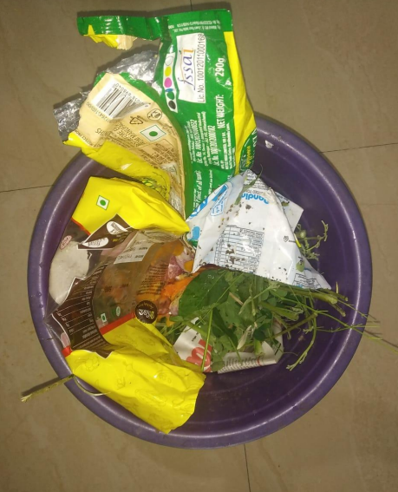

Fig 1: Dry and Wet waste segregation I

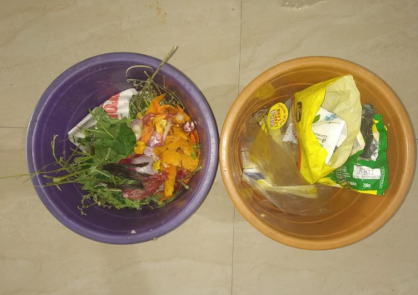

Fig 2: Dry and Wet waste segregation After

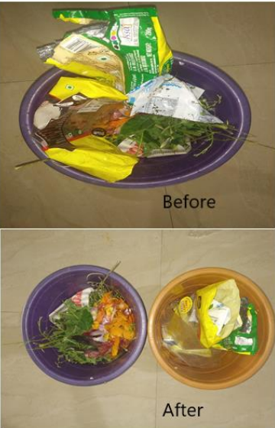

Fig 3: Before and After Segregating waste

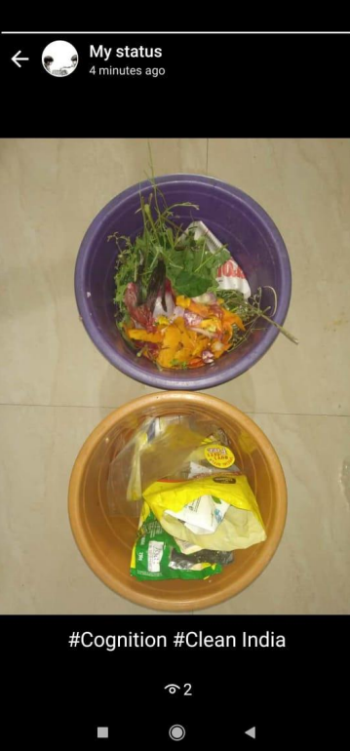

Fig 4: Influencing others to follow the segregation

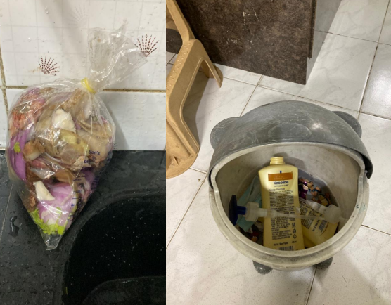

Fig 5: Impact of influence on neighbours and friends I

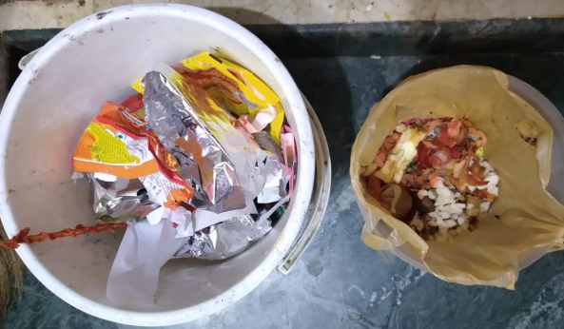

Fig 6: Impact of influence on neighbours and friends II

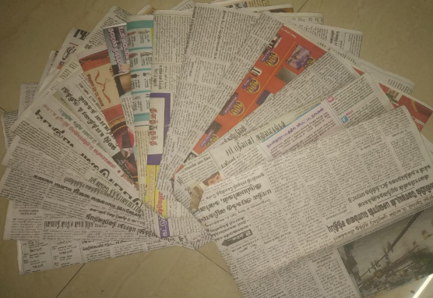

Fig 7: Creation of Paper bags

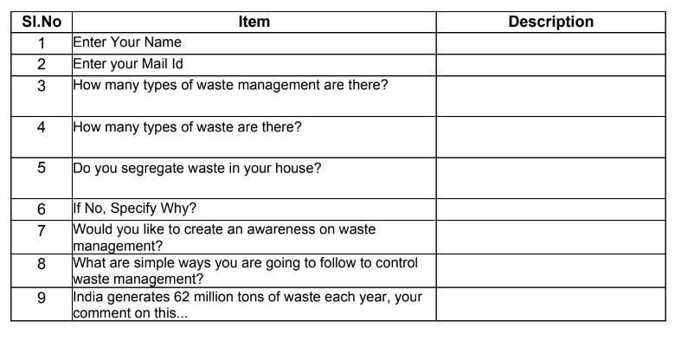

Fig 8: Annexure of the survey conducted

**3.1.6 Certificate**

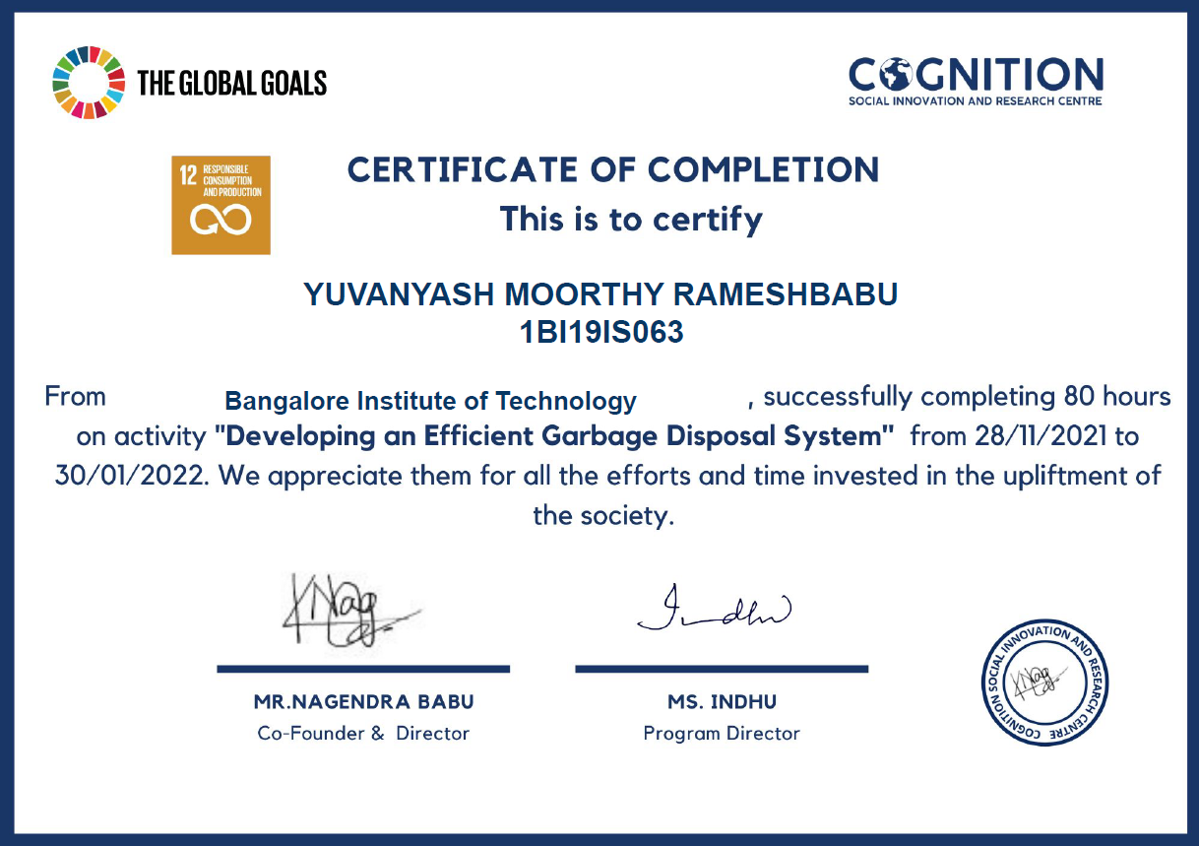

**Activity 2:100% Digitised Transaction**

**3.2.1 Introduction**

Digital India is a campaign launched by the Government of India to ensure the Government services are made available to citizens electronically by improved online infrastructure and by increasing Internet connectivity or by making the country digitally empowered in the field of technology.

The initiative includes plans to connect rural areas with high-speed internet networks.

Digital India consists of three core components:

(a) development of secure and stable digital infrastructure

(b) delivering government services digitally

(c) universal digital literacy.

Launched on 1 July 2015 by Prime Minister Narendra Modi, it is both enabler and beneficiary of other key Government of India schemes, such as BharatNet, Make in India, Startup India and Standup India, Industrial corridors, Bharatmala, Sagarmala, Dedicated Freight Corridors and UDAN-RCS.

The vision of Digital India programme is inclusive growth in areas of electronic services, products, manufacturing and job opportunities etc. and it is centered on three key areas – Digital Infrastructure as a Utility to Every Citizen, Governance & Services on Demand and Digital Empowerment of Citizens.

The motive behind the concept is to build participative, transparent and responsive system. All educational institutions and government services will soon be able to provide I-ways round the clock. Digital India will provide all services electronically and promote digital literacy. Digital Technologies which include the concept of cloud computing and mobile applications have emerged as the catalysts for express economic growth and citizen empowerment. Companies all over the world desire to invest in Digital India- the 21st century India, as a growth opportunity. Hence, an attempt has been made in this paper to understand Digital India – as a campaign where technologies and connectivity will come together to make an impact on all aspects of governance and improve the quality of life of citizens. Global investors like Sundar Pichai, Satya Nadella, Elon Musk have supported Modi's Digital India initiative.

The programme contains tasks that target to make sure that govt. services are available to people digitally and people get advantage of the newest information and connections technological innovation. Gandhiji felt that 'India resides in its villages,' and technology will help the villages to grow and prosper. Digital libraries, online magazines, e-books can be made available for free which will further help in knowledge sharing.

Technology is a bridge indeed, a bridge that connects the hope that India's villages will be educated and aware to the opportunity of internet and access to information from across the world. 'Digital India' is not just an initiative but a need for this country, where majority of population still does not have access to the world of internet. The Digital India initiative seeks to lay emphasis on e governance and transform India into a digitally empowered society. It is to ensure that government services are available to citizens electronically. Digital India also aims to transform ease of doing business in the country.

It will focus on providing high speed internet services to its citizens and make services available in real time for both online and mobile platform. Government is focusing on providing broadband services in all villages of the country, tele-medicine and mobile healthcare services and making the governance more participative.

India’s economy has witnessed a significant economic growth in the recent past by growing 7.3 per cent in 2015 as against 6.9 per cent in 2014. The steps taken by the government in recent times have shown positive results as India’s gross domestic product (GDP). The Digital India project itself will create employment opportunities for 17 million people directly or indirectly which will help in fighting against unemployment problems in India. Government has planned to give IT training to 100 million students in smaller towns and villages as employment opportunity in IT sector is very high in India.

In the next 5 years, India will emerge to be a leader in using IT in sectors like health, defense, education, agriculture and banking. Also, the service sectors will be digitally empowered. In the field of education, it also assures broadband connectivity in all panchayats, schools, libraries and other public places. Apart from Broadband connectivity, every village is provided with universal phone connectivity across the country. Mobile and internet banking can improve the financial inclusion in the country and can create win-win situation for all parties in the value-chain by creating an interoperable ecosystem and revenue sharing business models.

**3.2.2 Meaning Of 100% Digitised Transactions**

A digital transaction is a seamless system involving one or more participants, where transactions are affected without the need for cash. The digital transaction involves a constantly evolving way of doing things where financial technology (fintech) companies collaborate with various sectors of the economy for the purpose of meeting the increasingly sophisticated demands of the growing tech-savvy users. As the needs of investors and financial service users become more complex, there is a demand for effective tools to simplify the processes and transactions carried out by end-users. It is inevitable that financial institutions would have to increase the number of digitized services and offerings, given a rise in the use of automated services.

Implementing technology in the financial industry is a necessity for the survival of businesses as customers seek lower-cost alternatives to traditional financial services. Fintech companies have led the revolution in transforming the financial sector by digitalizing the end-client’s transactional eco-system. A digital transaction converts a traditional cash-operational society to a cashless one. It can be anything from paying for goods at a brick-and-mortar store to transferring money online to making investment trades.

The e-commerce portal has provided a means by which buyers and sellers can engage in digital transactions; cloud service platforms have provided a digital process for storing data; crowdfunding gateways have provided a means by which individuals and startups can have access to funds; peer-to-peer lending forums have provided a way for individuals to lend to and borrow from each other without the hassles of the traditional banking regulation.

Both parties, in essence, the payer and the payee, use electronic mediums to exchange money. Besides, it is far from the truth that digital payments take place only via the internet.

Payments made using any UPI equipped platform, via a cellular device, for the purchase of any physical goods can also be considered digital payments. For instance, every time you buy groceries from your nearby shop and pay using any of the available UPI options, you are making a digital payment.

Businesses and consumers are interested in secure and convenient payment methods, as cash has become obsolete in the wake of the COVID-19 pandemic. Digital payments are a method that is safer, easier to collect, and less expensive in the long run as compared to traditional methods of payments. Moreover, digital payments can be processed faster than cash in real-time. And, it can also accommodate any person and any business in the world.

Digital payments are made via the online secure bank network by transferring money from your customer account to your commercial bank account, depending on the platform you use. As soon as you collect the payment, the money flows directly into your business account without delay and at a fraction of the cost.

Digitalization means using digital technology as a part of everyday life. Digitization of payments helps a person to transfer money from his bank account to the payees for his day-to-day transactions. Modes of digital payments include a number of instruments under one umbrella which can be used as and when required. India is stepping in to the leadership role in the arena of internet age and is anticipating a growth in such a way people have more access to mobile than that of electricity connections at home. Thus, India is moving forward to the aim of Cash less Society which means paper currency in circulation will reduce to minimal and all payments are made through digital mechanism. The present study represents an added contribution to the currently on-going researches that are being done to decide whether digitization is important for the nation in the current economic situation. The study reaffirms that the importance of mobile penetration supported by the government initiatives constitute the most important drivers to enable people to move towards digital payment system.

India is also focusing on the digitization of payment system with a view to become Digital India in all aspects of functioning. The main aim of the country is to reduce the value of currency in circulation which is greater than of any emerging markets.

Technology always made human life easier. Electronic payment system is also to enable smooth and hassle-free payment system which is efficient, reliable and affordable. Payment system is backbone of any country and India need to make such decisions carefully and intelligently to make digitization its strength to grow stable.

**3.2.3 Activities Conducted**

The activity was to conduct a survey of how domestic workers are utilizing digitalization and how are they benefited or is it causing any problem and know their thoughts of if this process is the future form of buying and selling things.

First part of the activity was to prepare questions of the survey and it was a group activity each team had to come up with some 10-15 questions.

And then we had to begin the survey by asking questions to domestic workers, auto drivers to know how digital transaction like Paytm, Gpay has helped them.

To the advantages and the disadvantages, they are facing while using these types of transactions since they would have been used to money exchange and this is a recent development many might even not be aware of these types of transactions.

And there is lot of chances of frauds, if people don’t know how really this works and would be difficult for them and might lead to losses if continued.

To know their problems which we can bring notice to and spread awareness among people about the issues and provide solutions to their problems.

These types of digital transactions have been very useful especially in this pandemic time as there is no involvement of hand-to-hand transfer of money and everything being online and digital in covid times.

This type of digital transaction has gained improvement in pandemic time especially.

**3.2.4 Results and Findings**

Digital payment methods are often easy to make, more convenient and provide customers the flexibility to make payments from anywhere and at any time. These are a good alternative to traditional methods of payment and speeden up transaction cycles. Post demonetization, people slowly started embracing digital payments and even small-time merchants and shop owners started accepting payments through the digital mode.

Digital payments are much easier and safer than cash payments. They are much more convenient than cash payments as well. Since they are digital, you do not have to carry cash as well.

The main objectives of digital transactions are to reduce the costs and risks of handling cash and to increase the ease of conducting transactions. Since digital payments reduce the costs of providing poor people with financial services, they have become a vital tool in improving financial inclusion. The convenience and safety of using insurance, payments, and savings products also increase by using digital payments.

The main reasons for using digital payments are to improve the ease of conducting card/digital transactions for an individual and to reduce the risks and costs of handling cash at the individual level. Reduce costs of managing cash in the economy and build a transactions history to enable improved credit access and financial inclusion.

During the pandemic, our physical infrastructure was locked down in most places and while things will reopen gradually, this is no time to abandon the lessons learned in having a robust digital infrastructure that allowed us continuity. But there is a lot of work to be done to make the internet an essential service and accessible for over a billion people in India with the right devices and supporting an entirely new generation of entrepreneurs. The Industrial Revolution was a marathon runner, the digital revolution is turning out to be a race. The internet backbone is the new roads and bridge infrastructure for the digital economy and the future pace of growth depends on how well and how quick we build digital infrastructure. India’s 21st century depends on how the government along with private companies can join hands to expand this critical infrastructure.

**3.2.5 Observations and Learnings**

The adoption of digital payment solutions is picking up at a furious pace. Everyone from the neighbourhood vegetable vendor to the chai and bhelpuri-wala is embracing digital payment solutions to tide over the cash crunch. Debit cards, e-wallets and other digital platforms are witnessing a surge in volumes. An online survey which was conducted to find out the level of adoption of digital payment solutions and user habits. The findings reveal that while people are getting comfortable with cashless payments, some mindset issues are holding back many from embracing the newer platforms.

The findings also suggest that the usage habits of those who have taken to cashless modes could be exposing them to security threats. Those without mobile phones can now also transact digitally through Aadhaar based payments using just their fingerprints. E-wallet providers have also jumped at the opportunity. It is raining discounts and cashbacks in this segment, which is attracting more users on these platforms. Others service providers such as Paytm and MobiKwik have also been lining up cashback offers. The findings are suggestive that digital transformation in transaction banking is capable of reducing the operational costs and overheads leading to increased profits, improved efficiency, better regulatory controls with less risks and collaborative opportunities for partners in developing economy like India taking benefit of its tech talent.

**3.2.6 Attachments**

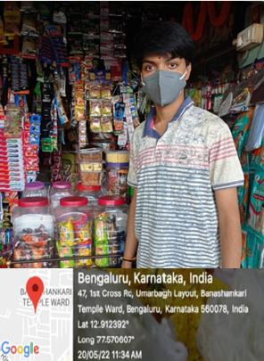

Fig 21: Survey Pictures I

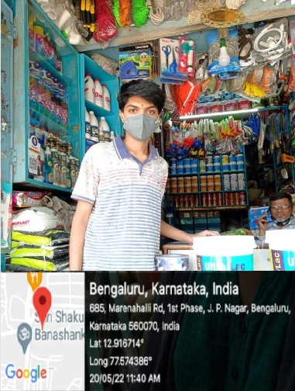

Fig 22: Survey Pictures II

**Responses**

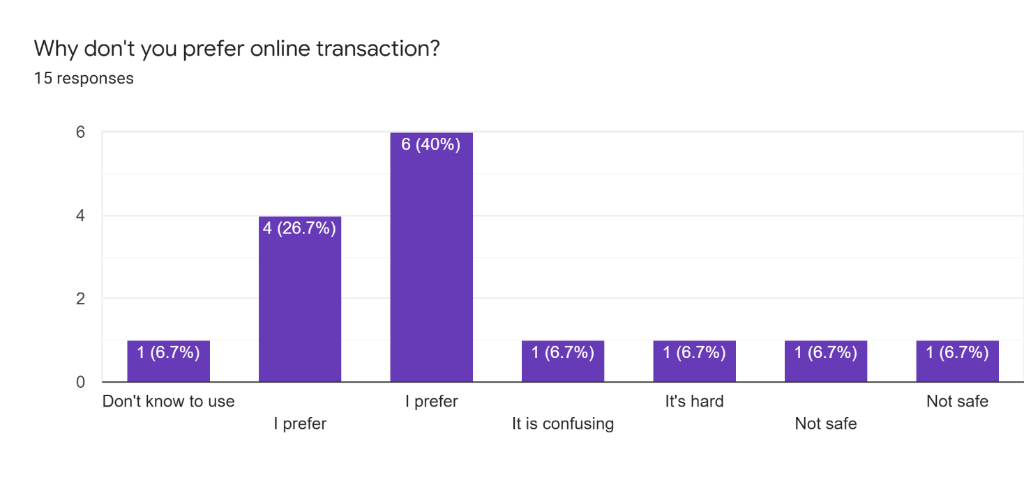

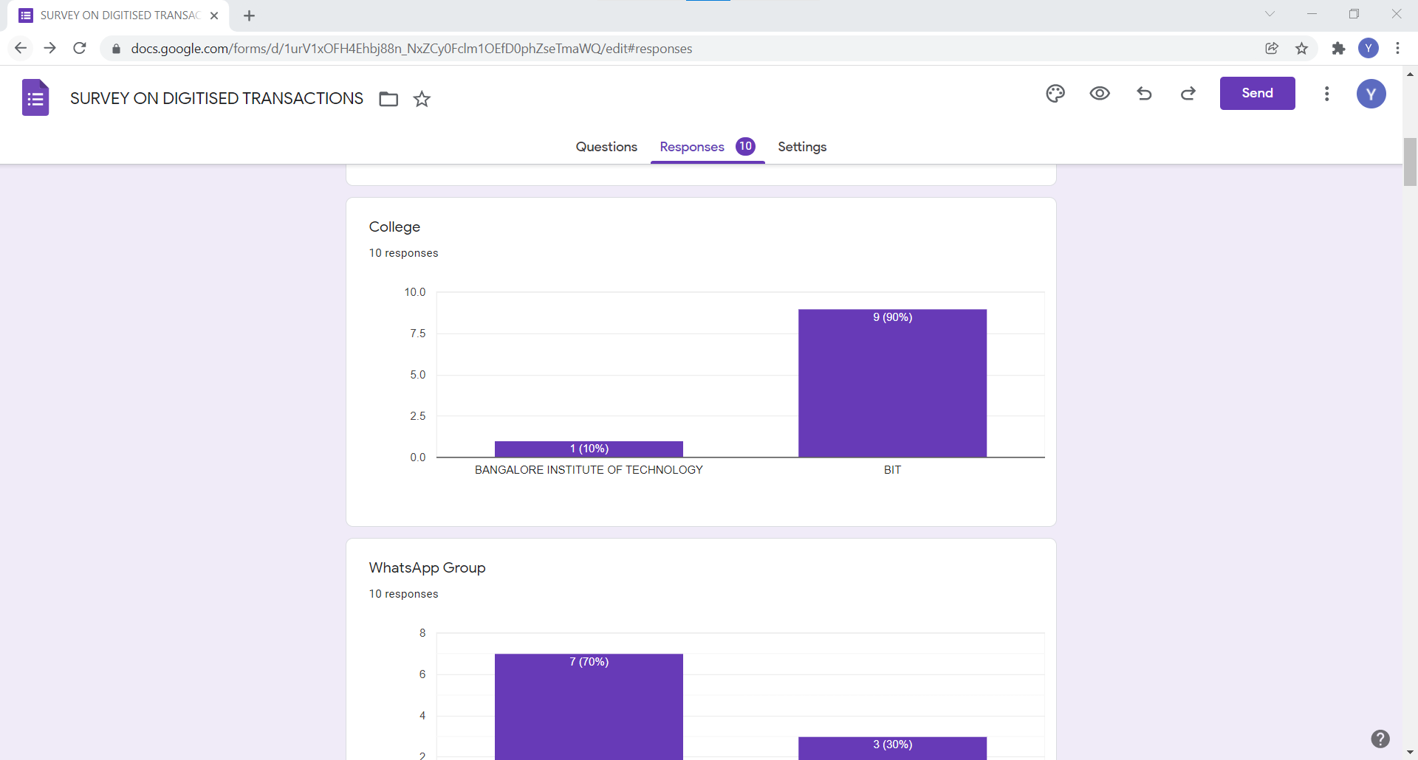

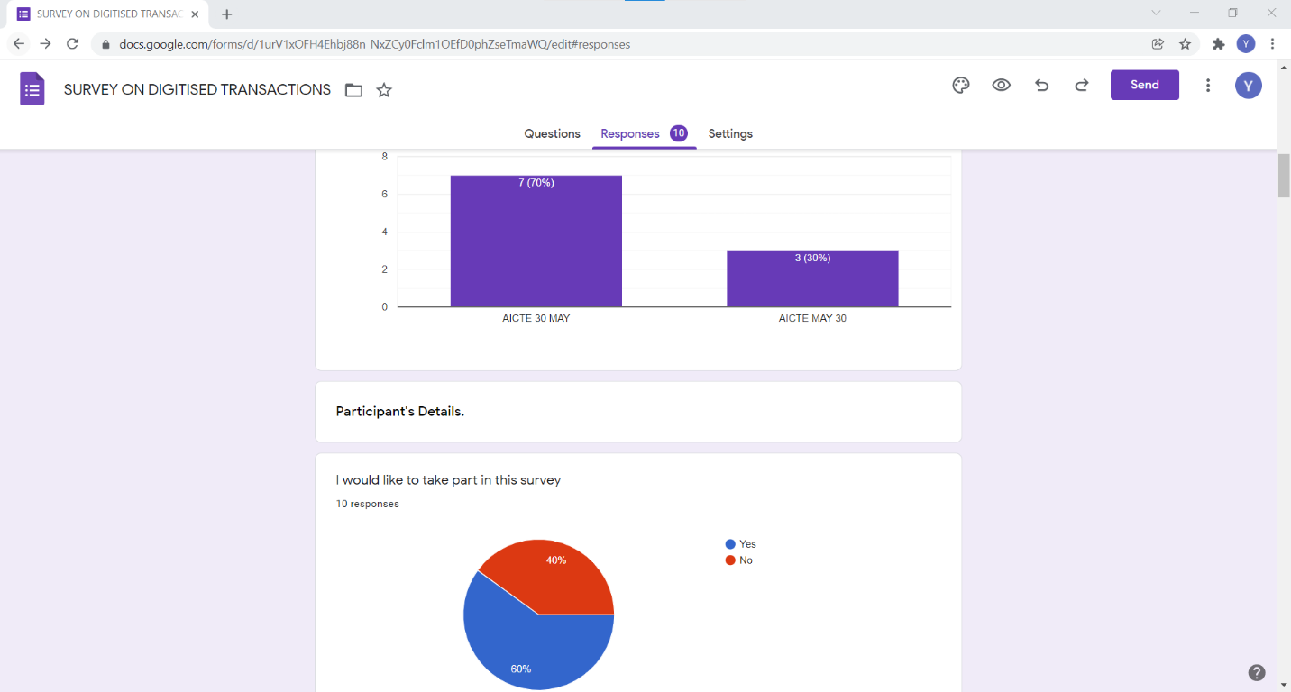

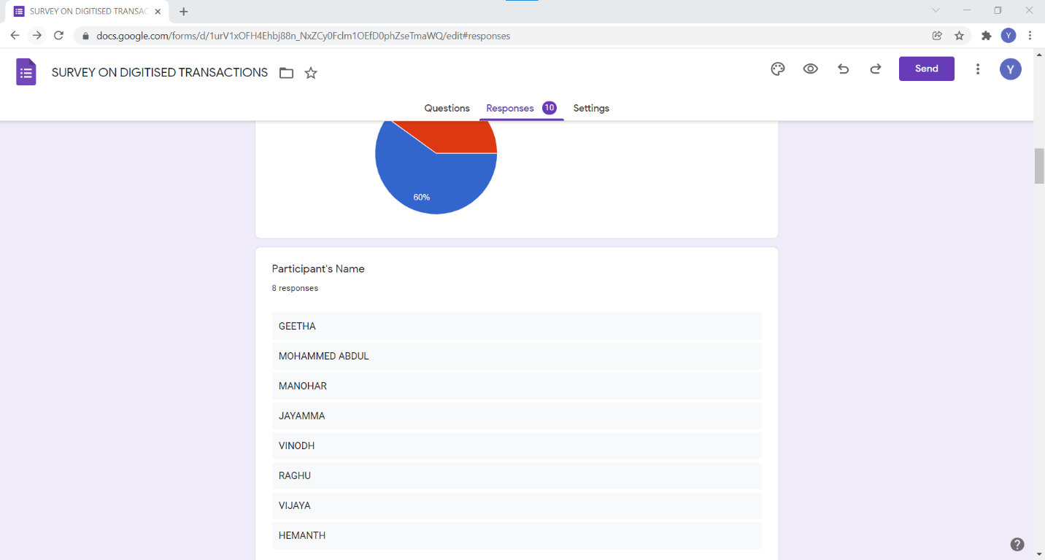

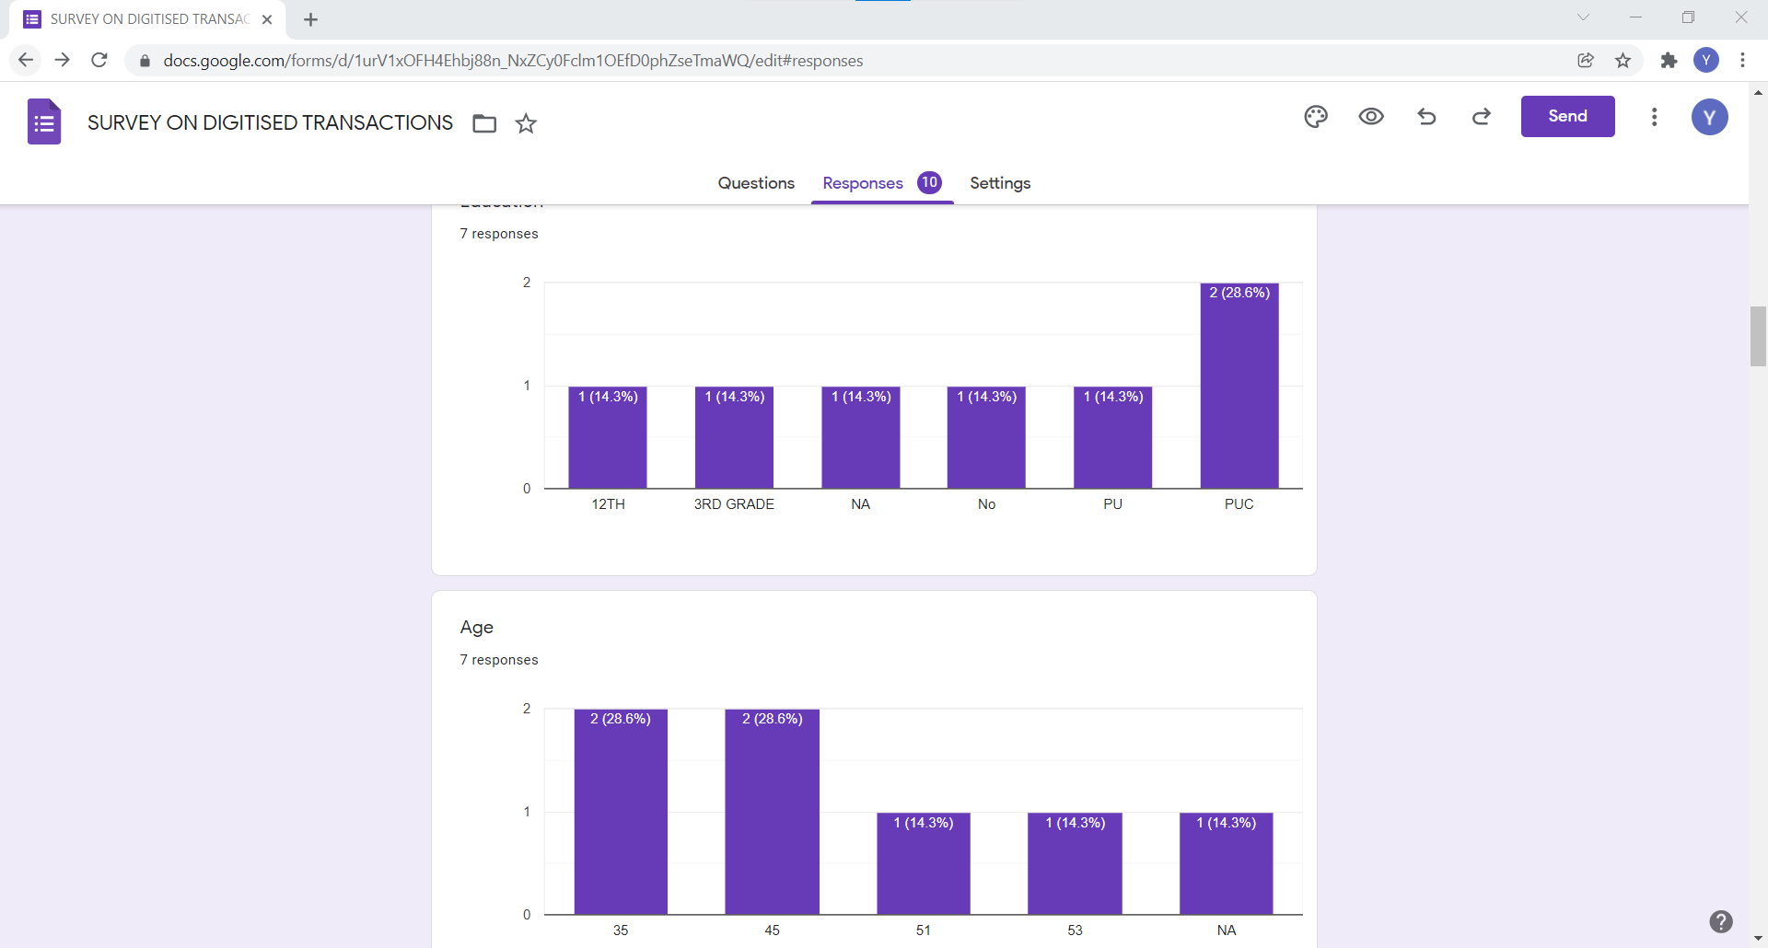

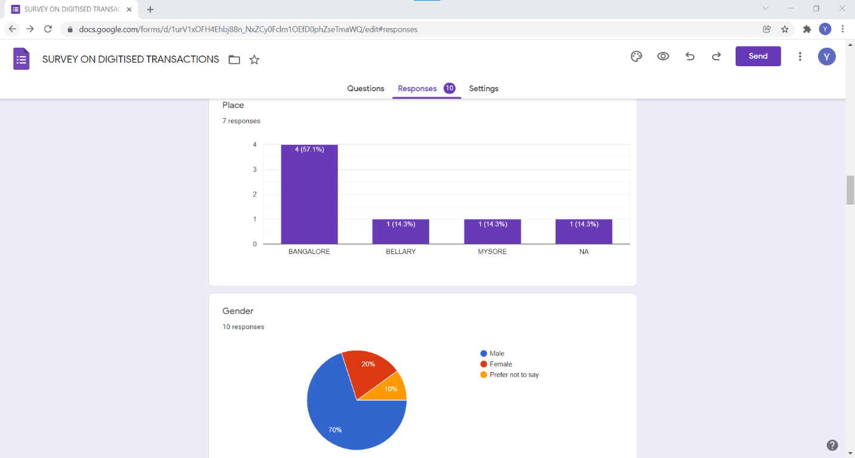

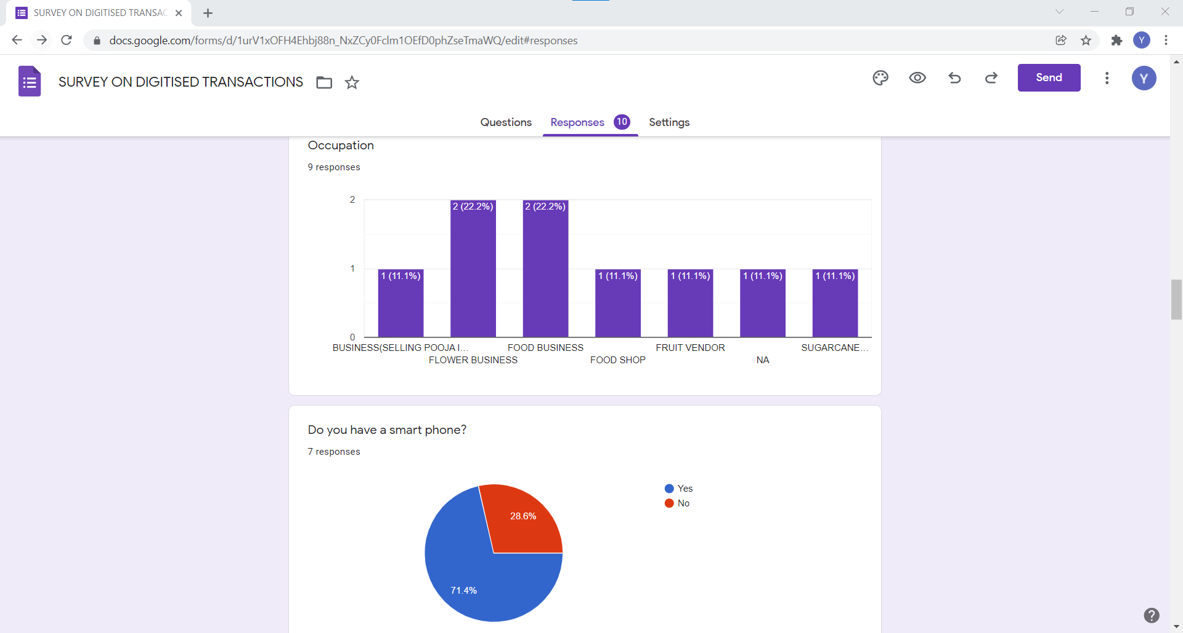

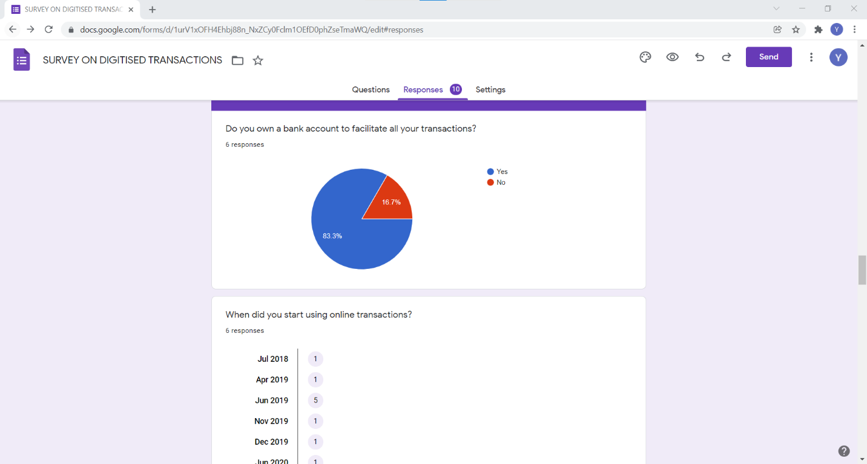

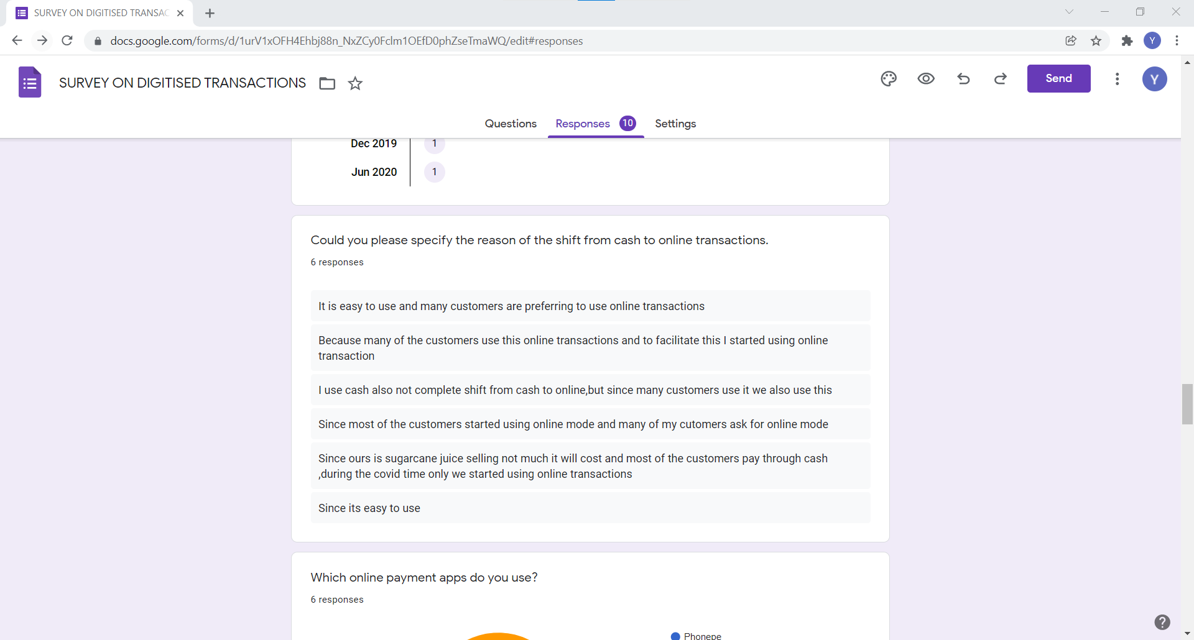

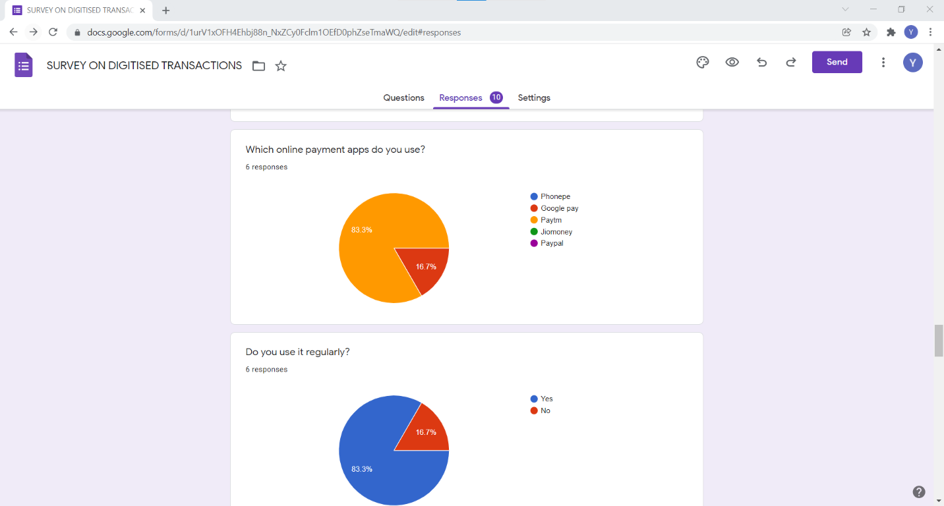

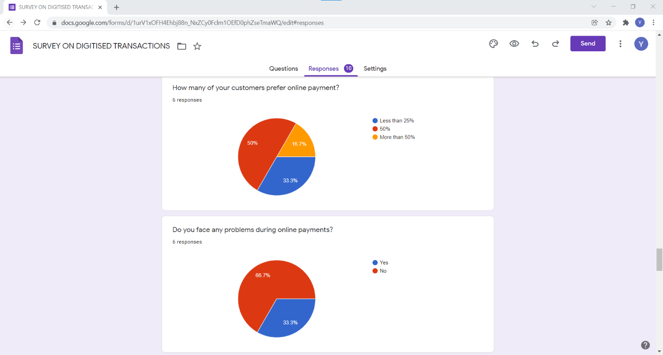

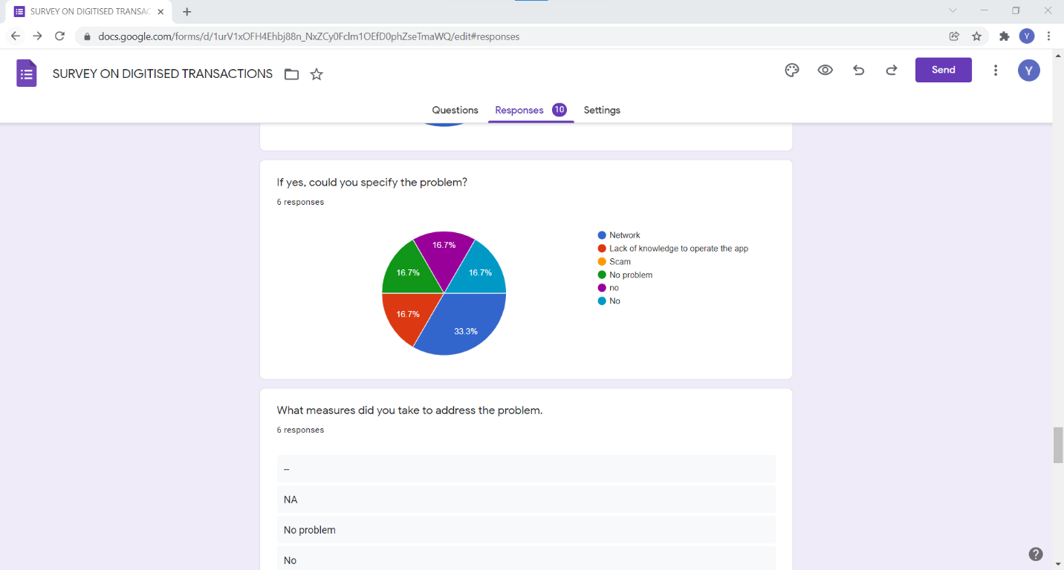

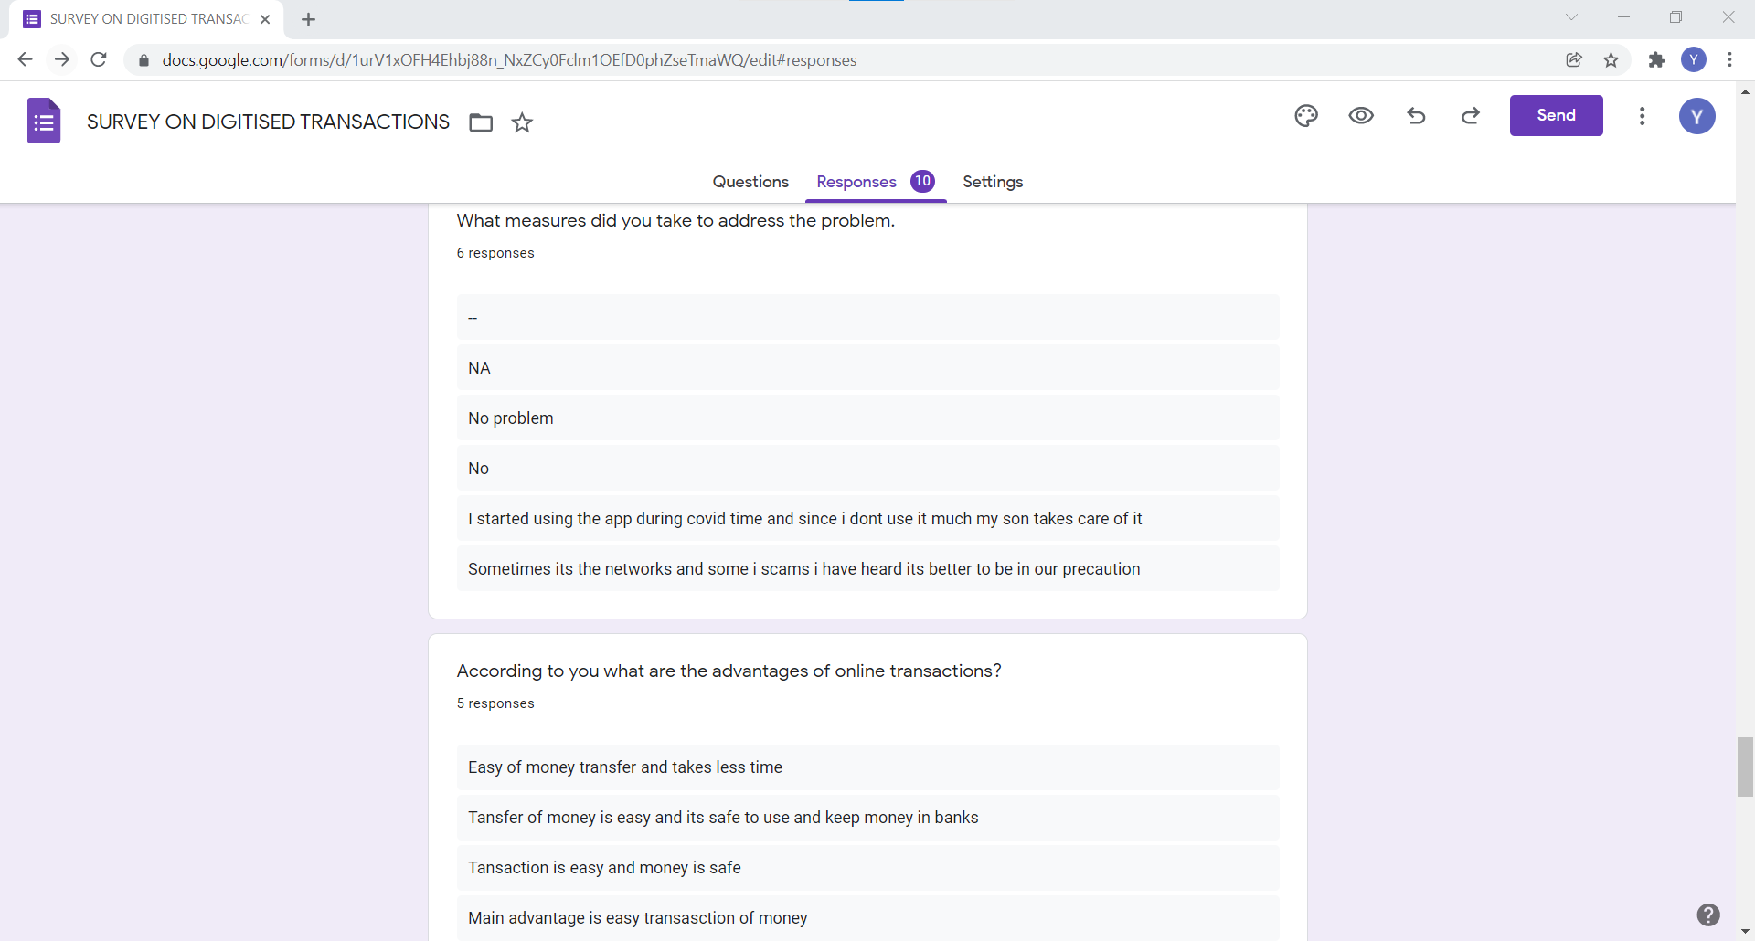

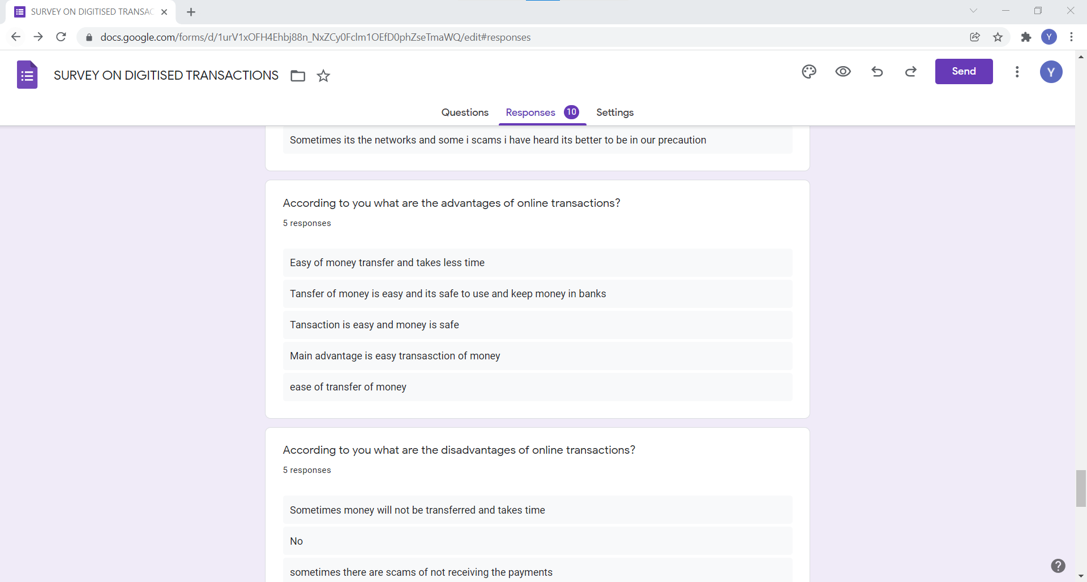

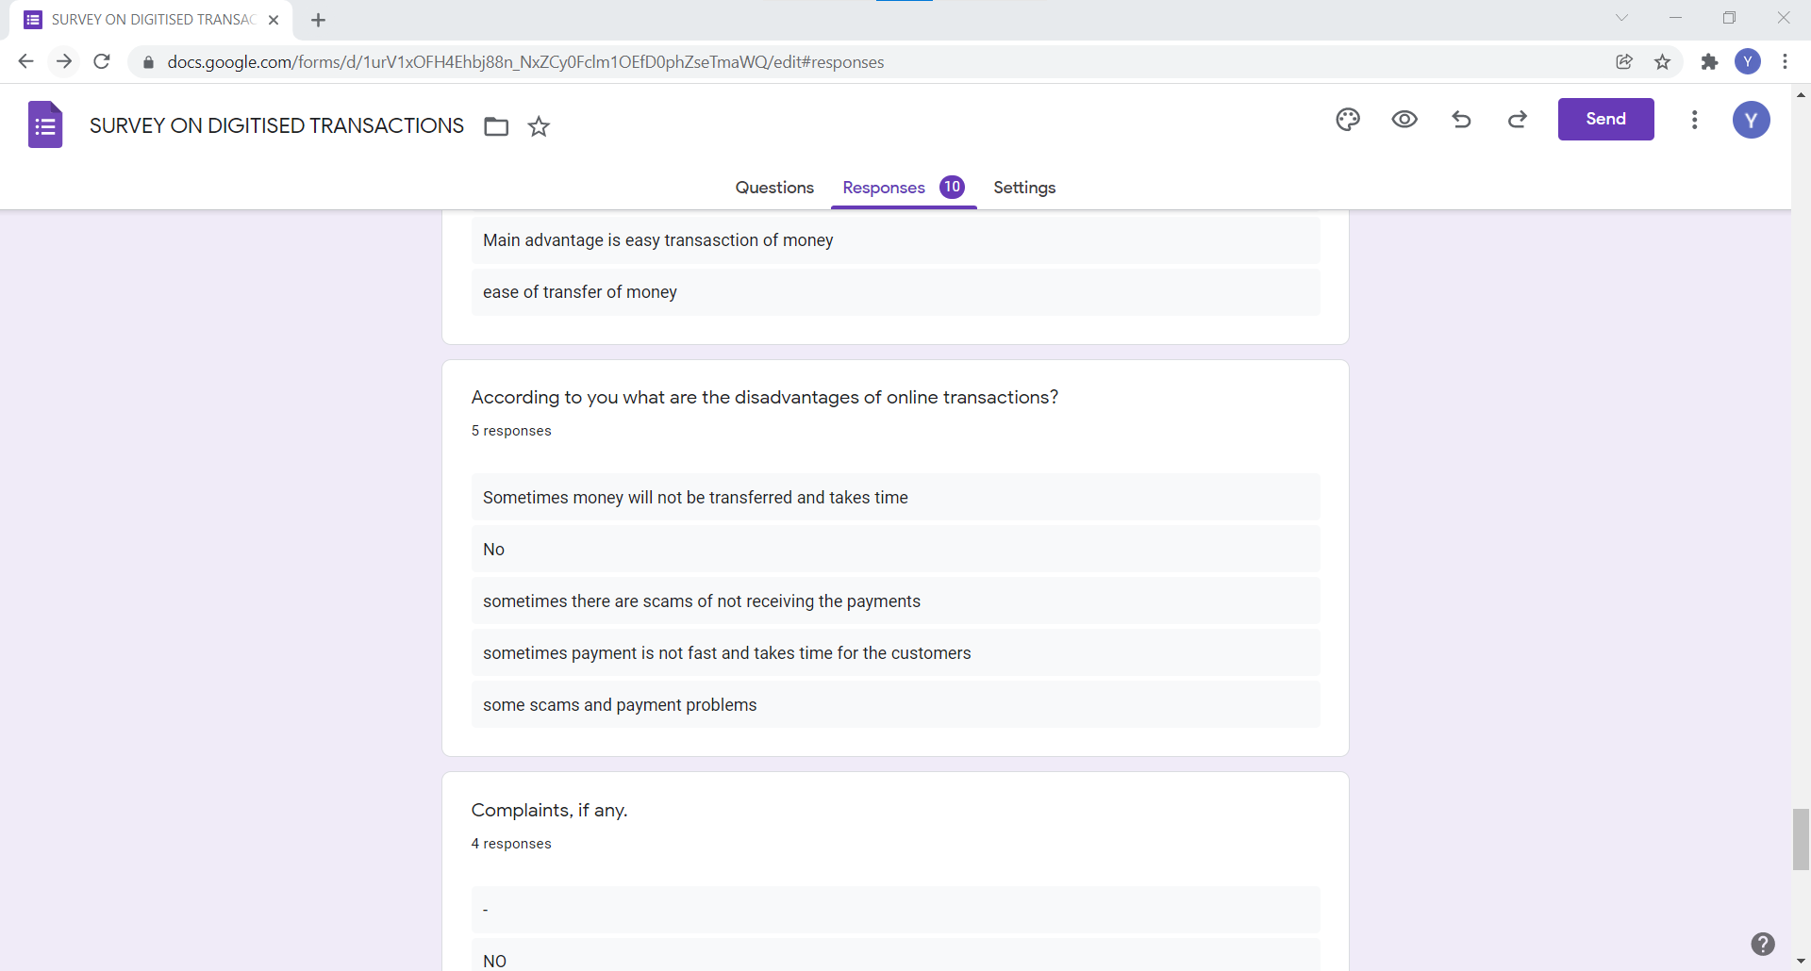

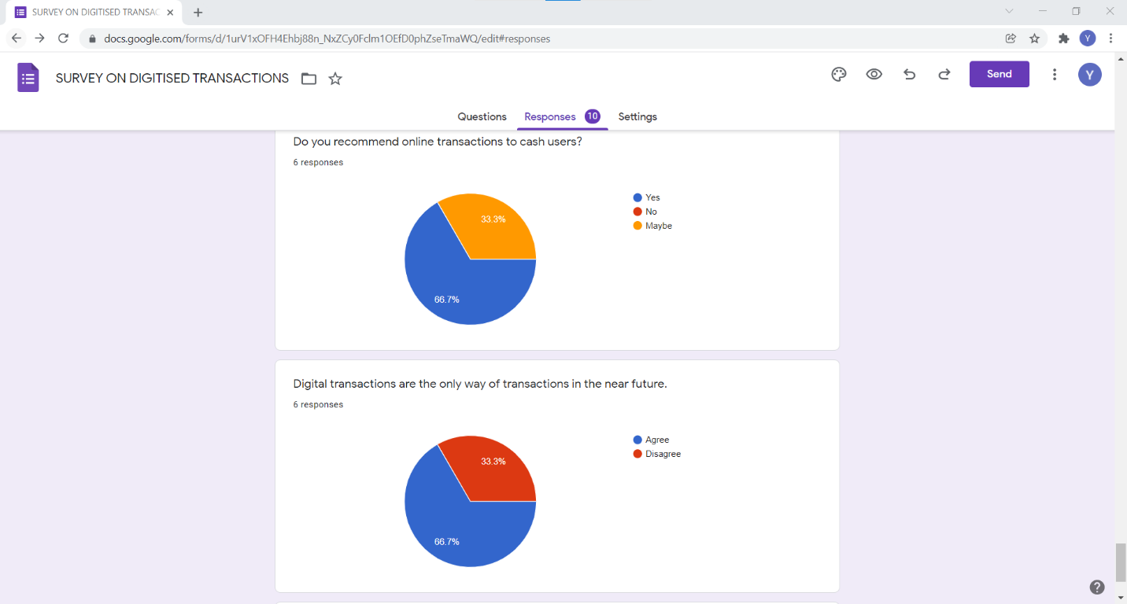

**3.2.7 Certificate**

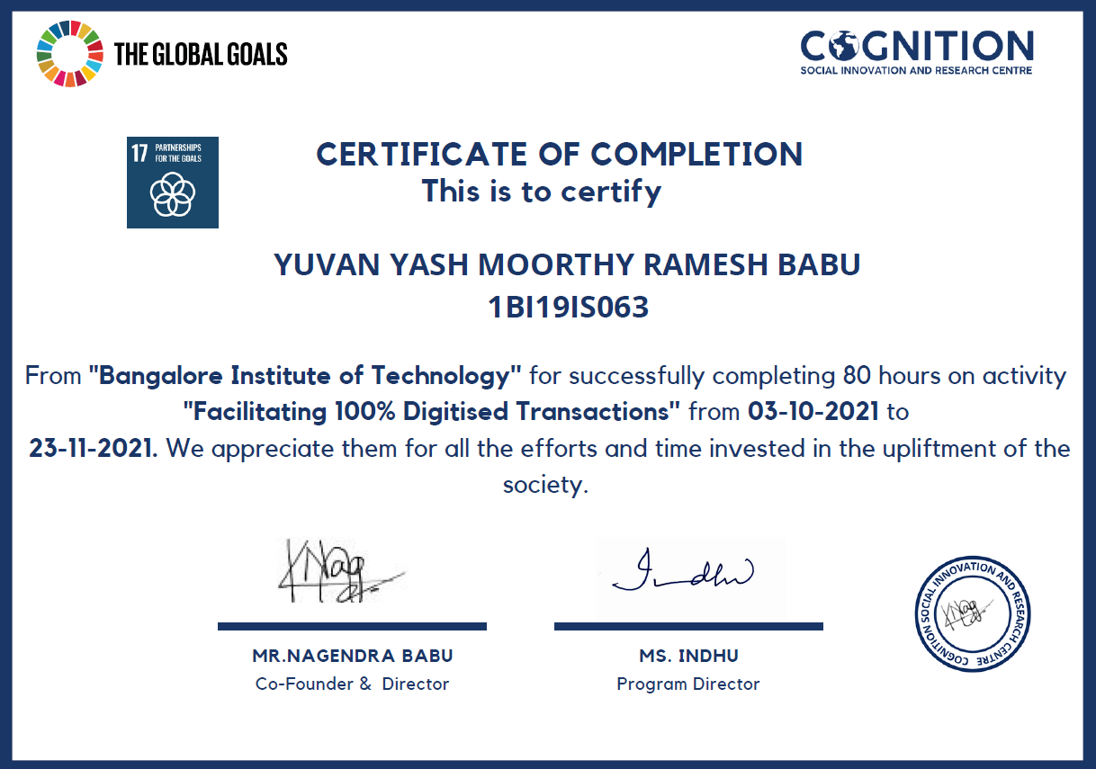

# ACTIVITY 3: Contributing by writing python programs to first semester student’s lab manual

Dr. K M Roopa, the Professor and Dean of Skill Development at the Department of Mathematics, BIT gave us an opportunity to earn activity points by writing python code for the junior batch (1st semester) students for their lab manual on the topic of **“2D Plot for polar and cartesian curves” and “Solution of system of linear equations using Gauss Seidel Iteration”**

The activity was conducted for three days and involved understanding the theory behind the polar and cartesian curves. The Python code allowed the students to implement the 2D Plot for polar and cartesian curves.

**CODE 1:**

import math

import numpy as np

import matplotlib.pyplot as plt

#function that returns cartesian

def y(x):

return x**2+x

#function that returns polar

def r(t):

return np.sin(t) + np.cos(t)

#function for cartesian plot

def plot_cartesian():

# list of values of x

xs = np.linspace(0, 4, 1000)

#to append the values in the graph for each value of xs

ys = [y(i) for i in xs]

#plot for the values of x and y

plt.plot(xs, ys)

#display the graph

plt.show()

def plot_polar():

#list of values of theta

ts = np.linspace(0, np.pi, 1000)

# to append the values in the graph for each value of ts

rs = [r(i) for i in ts]

# plot for the values of theta

plt.polar(ts, rs)

#display the graph

plt.show()

#call the functions defined

plot_cartesian()

plot_polar()

**OUTPUT 1:**

**2D plot for cartesian curve**

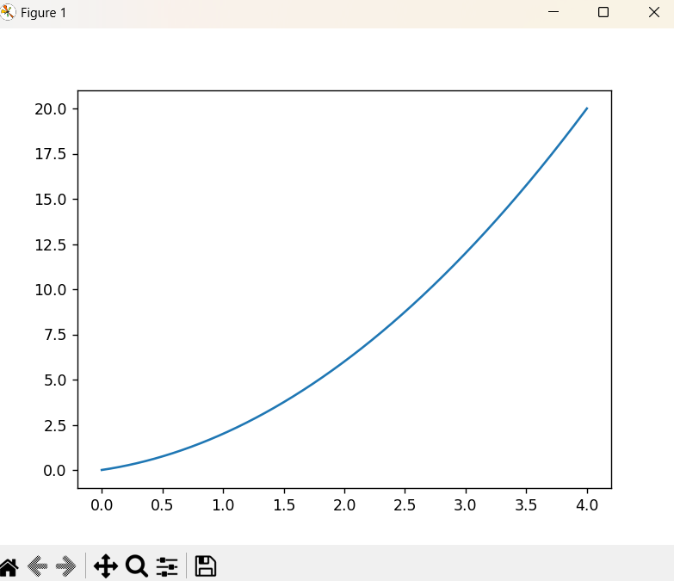

**OUTPUT 2:**

**2D plot for polar curve**

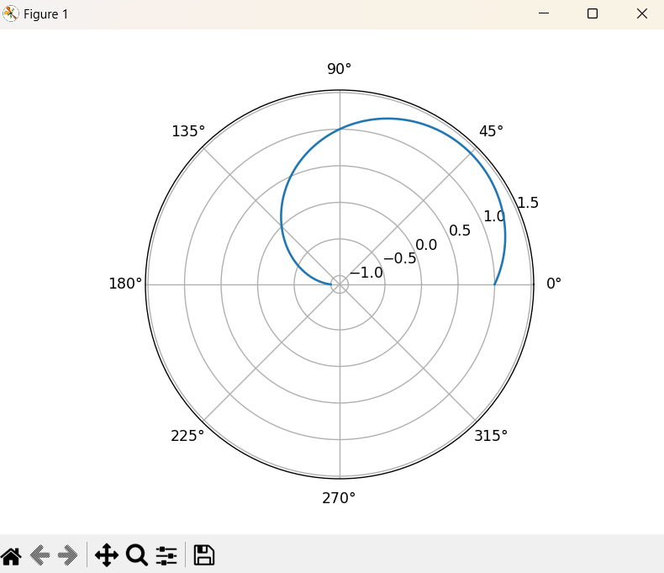

**CODE 2:**

# Gauss Seidel Iteration

# Defining equations to be solved

# in diagonally dominant form

# reeduce to the form of x y and z expressions

# create expressions for each using lambda to substitute the values

f1 = lambda x, y, z: (7 - y - z)

f2 = lambda x, y, z: (13 - x - z) / 3

f3 = lambda x, y, z: (13 - x - 2 * y) / 2

# Initial setup

x0 = 0

y0 = 0

z0 = 0

count = 1

# number of iterations

n = float(input('Enter total number of iterations: '))

# Implementation of Gauss Seidel Iteration

print('\nCount\tx\ty\tz\n')

condition = True

while condition:

x1 = f1(x0, y0, z0)

y1 = f2(x1, y0, z0)

z1 = f3(x1, y1, z0)

print('%d\t%0.4f\t%0.4f\t%0.4f\n' % (count, x1, y1, z1))

count = count + 1

x0 = x1

y0 = y1

z0 = z1

condition = count <= n

print('\nSolution: x=%0.3f, y=%0.3f and z = %0.3f\n' % (x1, y1, z1))

**OUTPUT 3:**

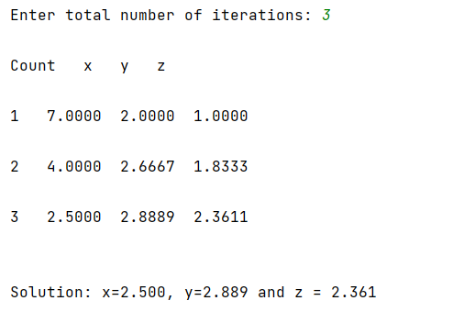

**OUTPUT 4:**

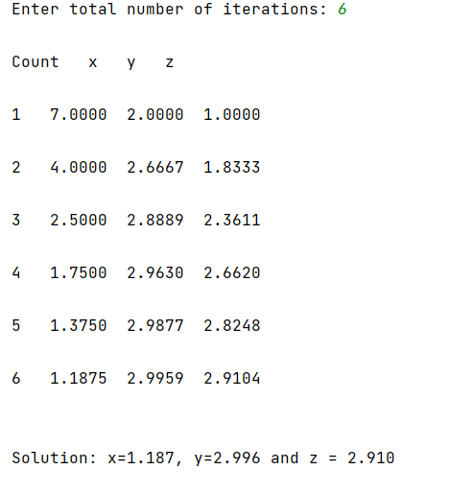

**4.****REFERENCES**

https://en.wikipedia.org/wiki/Waste_management

https://www.britannica.com/technology/solid-waste-management

<https://thecsrjournal.in/why-its-good-to-segregate-waste-at-home/>

https://en.wikipedia.org/wiki/Energy_conservation

https://www.electricalindia.in/energy-management-and-conservation/

<https://www.amrita.edu/course/energy-conservation-and-management>

https://india.wikia.org/wiki/Digital_India

https://www.investopedia.com/terms/d/digital-transaction.asp

<https://okcredit.in/blog/digital-payments-methods/>

https://midwestfloatingisland.com/10-ways-to-keep-your-lake-clean/

https://www.livemint.com/Money/zsQdQNmEkbfaKBKiavi5QN/A-new-way-to-clean-up-the-rivers-lakes.html

https://www.clean-flo.com/india-cleans/

https://organicabiotech.com/bio-solutions-bioremediation-sanitation-waste-management/lake-cleaning/

<https://brightside.me/wonder-people/a-man-from-peru-has-found-an-ingenious-way-to-clean-lakes-and-its-a-breakthrough-the-earth-was-crying-for-719560/>

https://pib.gov.in/Pressreleaseshare.aspx?PRID=1704822

https://www.globalbrandsmagazine.com/importance-of-womens-health/

https://www.bankbazaar.com/health-insurance/karnataka-govt-health-schemes-and-programmes.html